Ch7 - Packet Tracer Skills Integration Challenge

Topology Diagram

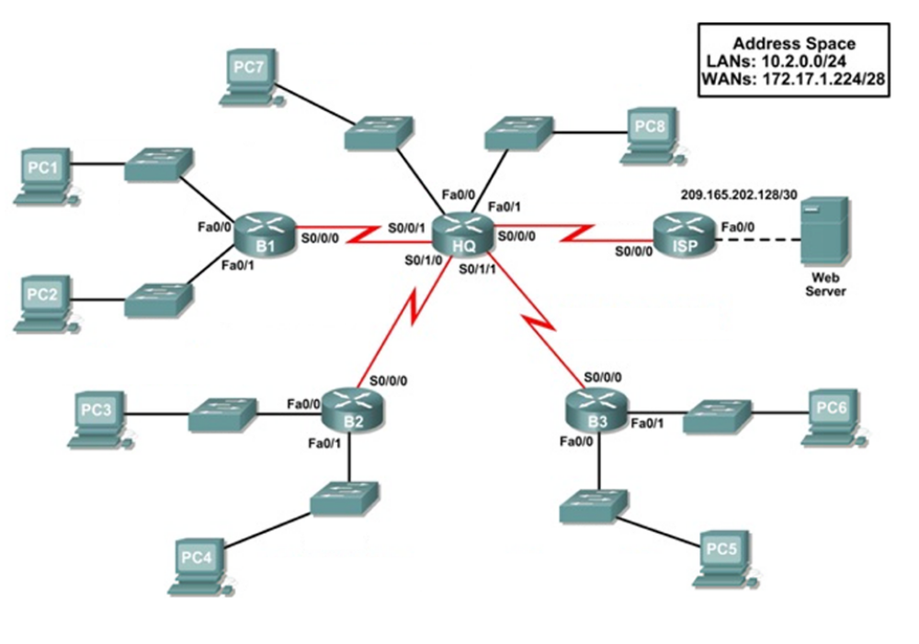

Addressing Table
Device | Interface | IP Address | Subnet Mask |  | Default Gateway
HQ | Fa0/0 | 10.2.0.225 |  | 255.255.255.248 | N/A
HQ | Fa0/1 | 10.2.0.233 |  | 255.255.255.248 | N/A
HQ | S0/0/0 | 209.165.201.2 |  | 255.255.255.252 | N/A
HQ | S0/0/1 | 172.17.1.225 |  | 255.255.255.252 | N/A
HQ | S0/1/0 | 172.17.1.229 |  | 255.255.255.252 | N/A
HQ | S0/1/1 | 172.17.1.233 |  | 255.255.255.252 | N/A
B1 | Fa0/0 | 10.2.0.1 |  | 255.255.255.192 | N/A
B1 | Fa0/1 | 10.2.0.65 |  | 255.255.255.192 | N/A
B1 | S0/0/0 | 172.17.1.226 |  | 255.255.255.252 | N/A
B2 | Fa0/0 | 10.2.0.129 |  | 255.255.255.224 | N/A
B2 | Fa0/1 | 10.2.0.161 |  | 255.255.255.224 | N/A
B2 | S0/0/0 | 172.17.1.230 |  | 255.255.255.252 | N/A
B3 | Fa0/0 | 10.2.0.193 |  | 255.255.255.240 | N/A
B3 | Fa0/1 | 10.2.0.209 | 255.255.255.240 |  | N/A
B3 | S0/0/0 | 172.17.1.234 | 255.255.255.252 |  | N/A
ISP | Fa0/0 | 209.165.202.129 | 255.255.255.252 |  | N/A
ISP | S0/0/0 | 209.165.201.1 | 255.255.255.252 |  | N/A
Web Server | NIC | 209.165.202.130 | 255.255.255.252 |  | 209.165.202.129
PC1 | NIC | 10.2.0.62 | 255.255.255.192 |  | 10.2.0.1
PC2 | NIC | 10.2.0.126 | 255.255.255.192 |  | 10.2.0.65
PC3 | NIC | 10.2.0.158 | 255.255.255.224 |  | 10.2.0.129
PC4 | NIC | 10.2.0.190 | 255.255.255.224 |  | 10.2.0.161
PC5 | NIC | 10.2.0.206 | 255.255.255.240 |  | 10.2.0.193
PC6 | NIC | 10.2.0.222 | 255.255.255.240 |  | 10.2.0.209
PC7 | NIC | 10.2.0.230 | 255.255.255.248 |  | 10.2.0.225
PC8 | NIC | 10.2.0.238 | 255.255.255.248 |  | 10.2.0.233

VLSM

B1 | Network | First | Last | Broadcast | Mask
Fa0/0 | 10.2.0.0 /26 | 10.2.0.1 /26 | 10.2.0.62 /26 | 10.2.0.63 /26 | 255.255.255.192
Fa0/1 | 10.2.0.64 /26 | 10.2.0.65 /26 | 10.2.0.126 /26 | 10.2.0.127 /26 | 255.255.255.192
B2 | Network | First | Last | Broadcast | Mask
Fa0/0 | 10.2.0.128 /27 | 10.2.0.129 /27 | 10.2.0.158 /27 | 10.2.0.159 /27 | 255.255.255.224
Fa0/1 | 10.2.0.160 /27 | 10.2.0.161 /27 | 10.2.0.190 /27 | 10.2.0.191 /27 | 255.255.255.224
B3 | Network | First | Last | Broadcast | Mask
Fa0/0 | 10.2.0.192 /28 | 10.2.0.193 /28 | 10.2.0.206 /28 | 10.2.0.207 /28 | 255.255.255.240
Fa0/1 | 10.2.0.208 /28 | 10.2.0.209 /28 | 10.2.0.222 /28 | 10.2.0.223 /28 | 255.255.255.240
HQ | Network | First | Last | Broadcast | Mask
Fa0/0 | 10.2.0.224 /29 | 10.2.0.225 /29 | 10.2.0.230 /29 | 10.2.0.231 /29 | 255.255.255.248
Fa0/1 | 10.2.0.232 /29 | 10.2.0.233 /29 | 10.2.0.238 /29 | 10.2.0.239 /29 | 255.255.255.248

WAN Links

WAN | Network | First | Last | Broadcast | Mask
HQ → B1 | 172.17.1.224 /30 | 172.17.1.225 /30 | 172.17.1.226 /30 | 172.17.1.227 /30 | 255.255.255.252
HQ → B2 | 172.17.1.228 /30 | 172.17.1.229 /30 | 172.17.1.230 /30 | 172.17.1.231 /30 | 255.255.255.252
HQ → B3 | 172.17.1.232 /30 | 172.17.1.233 /30 | 172.17.1.234 /30 | 172.17.1.235 /30 | 255.255.255.252

Introduction:

This Packet Tracer Skills Integration Challenge Activity is very similar to the activities you have created in prior chapters. To allow you to better practice your skills, the scenario is slightly different. In this activity, you build a network from the ground up. Starting with a given address space and network requirements, you must implement a network design that satisfies the specifications. Next, you implement an effective RIPv2 routing configuration with static and default routing for Internet access.

Objectives
- Design and document an addressing scheme based on requirements.
- Select appropriate equipment and cable the devices.
- Apply a basic configuration to the devices.
- Test connectivity between directly connected devices.
- Configure RIPv2 routing.
- Configure static and default routing for Internet access.
- Verify full connectivity between all devices in the topology.
Task 1: Design and document an addressing scheme.
Step 1: Design an addressing scheme.
Based on the network requirements shown in the topology, design an appropriate addressing scheme.
- Address the LANs in order starting with LAN 1, then LAN 2, etc. Use the first address for the router interface and the last address for the PC.
- The addressing requirements for the LANs are:
  - Router B1 interface Fa0/0 supports 60 hosts.
2^{x}-2 >= 60 → 2^{x}>= 62 → x=6 bits → 32-6= /26
  - Router B1 interface Fa0/1 supports 60 hosts.
2^{x}-2 >= 60 → 2^{x}>= 62 → x=6 bits → 32-6= /26
  - Router B2 interface Fa0/0 supports 30 hosts.
2^{x}-2 >= 30 → 2^{x}>= 32 → x=5 bits → 32-5= /27
  - Router B2 interface Fa0/1 supports 30 hosts.
2^{x}-2 >= 30 → 2^{x}>= 32 → x=5 bits → 32-5= /27
  - Router B3 interface Fa0/0 supports 10 hosts.
2^{x}-2 >= 10 → 2^{x}>= 12 → x=4 bits → 32-6= /28
  - Router B3 interface Fa0/1 supports 10 hosts.
2^{x}-2 >= 10 → 2^{x}>= 12 → x=4 bits → 32-6= /28
  - Router HQ interface Fa0/0 supports 5 hosts.
2^{x}-2 >= 5 → 2^{x}>= 7 → x=3 bits → 32-3= /29
  - Router HQ interface Fa0/1 supports 5 hosts.
2^{x}-2 >= 5 → 2^{x}>= 7 → x=3 bits → 32-3= /29
- Address the WANs in order starting with WAN 1, then WAN 2, etc. HQ is the first usable address in all WAN links, with the exception of the link to ISP. For the ISP link, HQ uses the second usable address.
  - WAN 1 is the link between HQ and B1.
2^{x}-2 >= 2 → 2^{x}>= 4 → x=2 bits → 32-2= /30
  - WAN 2 is the link between HQ and B2.
2^{x}-2 >= 2 → 2^{x}>= 4 → x=2 bits → 32-2= /30
  - WAN 3 is the link between HQ and B3.
2^{x}-2 >= 2 → 2^{x}>= 4 → x=2 bits → 32-2= /30
Step 2: Document the addressing scheme.
- Record the network addresses in dotted-decimal/slash format.
- Document the IP addresses, subnet masks and default gateway addresses.
Task 2: Apply a basic configuration.
Step 1: Configure the routers.
Using your documentation, configure the routers with basic configurations, including addressing and hostnames. Use cisco as the line passwords (console and Telnet). Use class as the enable secret password.
Step 2: Configure the PCs.
Using your documentation, configure the PCs with an IP address, subnet mask, and default gateway.
Task 3: Test connectivity.
Before continuing, make sure that each device can ping its directly connected neighbor.
Task 4: Configure and verify RIPv2 routing.
Step 1: Configure RIPv2.
Configure all devices with RIPv2 routing. In your configuration, make sure you include the following:
- Disable automatic summarization.
- Stop routing updates on interfaces that are not connected to RIP neighbors.
- Set a default route from HQ to ISP using the next-hop IP address.
- Configure static routes on the ISP using the outbound interface.
- Redistribute default route from HQ.
Step 2: Verify RIPv2.
Use verification commands to check your configuration. All routers should be converged on all the 10.2.0.0/24 and 172.17.1.224/28 subnets.
Task 5: Test connectivity and examine the configuration.
Test connectivity and examine the configuration.

